Chapter 01

1. Which of the following is used by all living things as the carrier of genetic information?
 | a. | Cell
 | b. | DNA
 | c. | Organ
 | d. | Molecule
 | e. | Population

ANSWER: | b

2. The smallest unit of life that can exist as a separate entity is a(n) ___________.
 | a. | cell
 | b. | molecule
 | c. | organ
 | d. | population
 | e. | ecosystem

ANSWER: | a

3. The most inclusive level of organization is exemplified by which of the following?
 | a. | Heart
 | b. | Carbon atom
 | c. | DNA
 | d. | Zebra
 | e. | Red blood cell

ANSWER: | d

4. What is the correct ordering in the hierarchal levels of the organization of life, from the least inclusive to the most inclusive?
 | a. | Atoms, tissues, cells, organs, and organisms
 | b. | Molecules, cells, organs, tissues, and organisms
 | c. | Ecosystems, populations, tissues, cells, and organs
 | d. | Cells, tissues, organs, communities, and populations
 | e. | Cells, tissues, organs, organisms, and ecosystems

ANSWER: | e

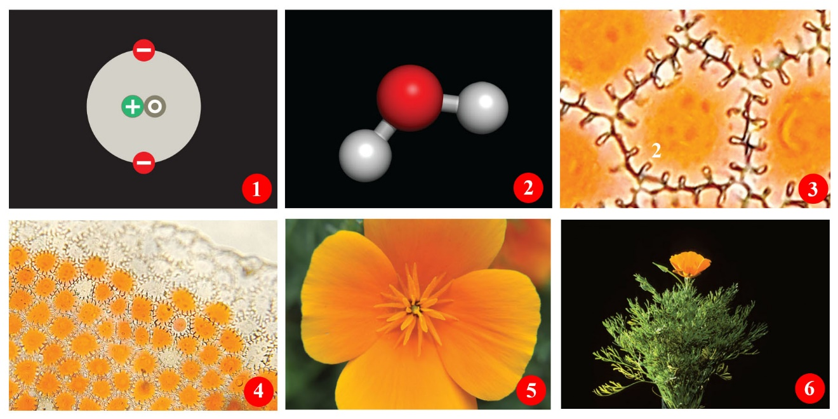
Figure 1.3

5. What is represented in frame 5 of Figure 1.3, illustrating the levels of life’s organization?
 | a. | Atom
 | b. | Tissue
 | c. | Molecule
 | d. | Organ
 | e. | Cell

ANSWER: | d

Figure 1.3

6. In Figure 1.3, illustrating the levels of life’s organization, what is represented in frame 3?
 | a. | Atom
 | b. | Tissue
 | c. | Molecule
 | d. | Organ
 | e. | Cell

ANSWER: | e

7. A community
 | a. | includes all populations of all species in a given area.
 | b. | features the living organisms interacting with the physical and chemical environment.
 | c. | is the sum of all places in Earth's atmosphere, crust, and waters where organisms live.
 | d. | includes members of only one species.
 | e. | is at a higher level of organization than an ecosystem.

ANSWER: | a

8. At what level of organization does life begin?
 | a. | Reproductive organs
 | b. | Cell
 | c. | Molecule (water)
 | d. | Molecule (DNA)
 | e. | Population

ANSWER: | b

9. Living organisms are members of all of the levels listed below. However, rocks are components of _____.
 | a. | the community
 | b. | the population
 | c. | the ecosystem only
 | d. | the biosphere only
 | e. | both the ecosystem and the biosphere

ANSWER: | e

10. A(n) ____ property is a characteristic of a system that does not appear in any of its component parts.
 | a. | symbiotic
 | b. | emergent
 | c. | synergistic
 | d. | energetic
 | e. | living

ANSWER: | b

11. Which feature is not characteristic of all living organisms?
 | a. | All have requirements for energy.
 | b. | All must participate in one or more nutrient cycles.
 | c. | All have ultimate dependence upon the sun.
 | d. | All interact with other forms of life.
 | e. | All must reproduce inside of organisms of other species.

ANSWER: | e

12. Four of the following are key characteristics for the survival of a species. Which one is the exception?
 | a. | Ability to acquire energy and nutrients
 | b. | Response to environmental change
 | c. | Reproduction
 | d. | Inability to change
 | e. | Ability to grow and adapt through changes in DNA

ANSWER: | d

13. Four of the following characteristics are required for the life of an individual organism to continue. Which is the exception?
 | a. | To maintain chemical uniqueness and organization
 | b. | To respond to stimuli
 | c. | To possess a genetic program to control cell processes
 | d. | To reproduce
 | e. | To evolve

ANSWER: | e

14. The conversion of solar energy to chemical energy is known as ______.
 | a. | metabolism
 | b. | photosynthesis
 | c. | chemosynthesis.
 | d. | catabolism
 | e. | anabolism

ANSWER: | b

15. Which of the following is a substance that an organism needs for growth and survival but cannot make for itself?
 | a. | Sunlight
 | b. | Water
 | c. | Nutrient
 | d. | Chlorophyll
 | e. | ATP

ANSWER: | c

16. Which of the following makes its own food using energy and simple raw materials it obtains from nonbiological sources?
 | a. | Producer
 | b. | Nutrient
 | c. | Consumer
 | d. | Cell
 | e. | Protist

ANSWER: | a

17. Which group of organisms does not depend directly on sunlight for energy?
I. Terrestrial producers
II. Animal consumers
III. Decomposers
 | a. | I only
 | b. | II and III only
 | c. | II only
 | d. | III only
 | e. | I and III

ANSWER: | b

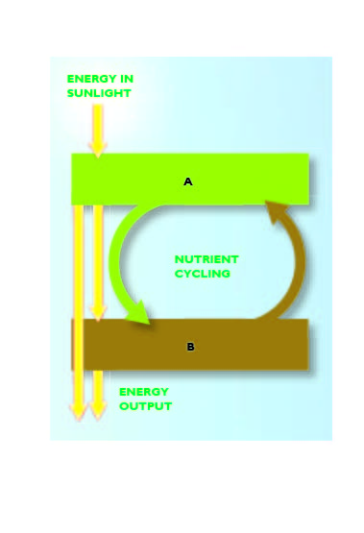
Figure 1.4

18. In Figure 1.4, "A" and "B" should be labeled, respectively, ____ and _____.
 | a. | consumers; producers
 | b. | decomposers; producers
 | c. | producers; redistributors
 | d. | producers; consumers
 | e. | consumers; decomposers

ANSWER: | d

19. The process by which the first cell of a new individual gives rise to a multicell adult is called _______.
 | a. | reproduction
 | b. | development
 | c. | growth
 | d. | inheritance
 | e. | homeostasis

ANSWER: | b

20. The flow of energy through living organisms is best characterized as ___.
 | a. | circular
 | b. | increasing
 | c. | a lattice
 | d. | one way
 | e. | lossless

ANSWER: | d

21. Homeostasis provides what kind of internal environment?
 | a. | Positive
 | b. | Stable
 | c. | Limiting
 | d. | Changing
 | e. | Chemical and physical

ANSWER: | b

22. Each cell is able to maintain an internal environment within a range that favors survival. This condition is called ___________.
 | a. | metabolism
 | b. | homeostasis
 | c. | physiology
 | d. | adaptation
 | e. | evolution

ANSWER: | b

23. About twelve to twenty-four hours after the previous meal, a person's blood-sugar level normally varies from 60 to 90 milligrams per 100 milliliters of blood, though it may rise to 130 mg/100 ml after meals high in carbohydrates. That the blood-sugar level is maintained within a fairly narrow range despite uneven intake of sugar is due to the body's ability to carry out ______.
 | a. | adaptation
 | b. | inheritance
 | c. | metabolism
 | d. | homeostasis
 | e. | evolution

ANSWER: | d

24. Which phrase would most likely be used in a discussion of homeostasis?
 | a. | Respond to environmental stimuli
 | b. | Limited range of variation
 | c. | Rapid energy turnover
 | d. | Both respond to environmental stimuli and limited range of variation
 | e. | Both respond to environmental stimuli and rapid energy turnover

ANSWER: | b

25. What characteristic is common to all living things?
 | a. | All living things eat.
 | b. | All living things are producers.
 | c. | All living things sense and respond to change.
 | d. | All living things have a nucleus.
 | e. | All living things are consumers.

ANSWER: | c

26. Energy sources are needed for which of the following processes?
I. Reproduction
II. Growth
III. Development
 | a. | I and II only
 | b. | I and III only
 | c. | II only
 | d. | II and III only
 | e. | I, II, and III

ANSWER: | e

27. Which cell lacks a nucleus?
 | a. | Bacterial cell
 | b. | Fungus cell
 | c. | Animal cell
 | d. | Protist cell
 | e. | Plant cell

ANSWER: | a

28. Members of which prokaryotic domain are most closely related to eukaryotes evolutionarily?
 | a. | Animals
 | b. | Protists
 | c. | Fungi
 | d. | Bacteria
 | e. | Archaea

ANSWER: | e

29. Which of the following is a domain of life?
 | a. | Eukaryotes
 | b. | Plants
 | c. | Animals
 | d. | Protists
 | e. | Fungi

ANSWER: | a

30. Members of what group are multicellular producers?
 | a. | Animals
 | b. | Protists
 | c. | Fungi
 | d. | Plants
 | e. | Bacteria

ANSWER: | d

31. Which group is made up of almost exclusively decomposers?
 | a. | Plants
 | b. | Fungi
 | c. | Animals
 | d. | Bacteria
 | e. | Protists

ANSWER: | b

32. Which organisms are NOT eukaryotes?
 | a. | Fungi
 | b. | Bacteria
 | c. | Mosses
 | d. | Fish
 | e. | Yeasts

ANSWER: | b

33. A scientific name consists of which of the following?
I. Family name
II. Genus name
III. Species name
 | a. | I only
 | b. | II only
 | c. | III only
 | d. | I and II
 | e. | II and III

ANSWER: | e

34. The plural for genus is ________.
 | a. | genus
 | b. | geni
 | c. | genera.
 | d. | gena
 | e. | genae

ANSWER: | c

35. Which is the least inclusive of the taxonomic categories listed below?
 | a. | Family
 | b. | Phylum
 | c. | Class
 | d. | Order
 | e. | Genus

ANSWER: | e

36. Which group includes all of the other groups?
 | a. | Domain
 | b. | Order
 | c. | Family
 | d. | Genus
 | e. | Species

ANSWER: | a

37. What is the process of transmission of DNA to offspring that occurs during reproduction?
 | a. | Inheritance
 | b. | Development
 | c. | Growth
 | d. | Photosynthesis
 | e. | Homeostasis

ANSWER: | a

38. Which term refers to judging information before accepting it as fact?
 | a. | Critical thinking
 | b. | Law
 | c. | Theory
 | d. | Fact
 | e. | Hypothesis

ANSWER: | a

39. Which term refers to the first explanation of a problem (sometimes referred to an "educated guess")?
 | a. | Principle
 | b. | Law
 | c. | Theory
 | d. | Fact
 | e. | Hypothesis

ANSWER: | e

40. What is a hypothesis?
 | a. | A report of the findings of scientific experiments
 | b. | A specific conclusion of an experiment in an "if … then" format
 | c. | A way of using isolated facts to reach a general idea that may explain a phenomenon
 | d. | The summary of the outcomes of scientific findings
 | e. | A testable explanation of a natural phenomenon

ANSWER: | e

41. Which concept represents the lowest degree of certainty?
 | a. | Hypothesis
 | b. | Conclusion
 | c. | Fact
 | d. | Principle
 | e. | Theory

ANSWER: | a

42. Which concept represents the highest degree of certainty?
 | a. | Hypothesis
 | b. | Deduction
 | c. | Assumption
 | d. | Theory
 | e. | Prediction

ANSWER: | d

43. The control in an experiment _______.
 | a. | makes the experiment valid
 | b. | is an additional replicate for statistical purposes
 | c. | reduces the experimental errors
 | d. | minimizes experimental inaccuracy
 | e. | allows for comparisons to the experimental group

ANSWER: | e

44. In an experiment, the control group is __________.
 | a. | not subjected to experimental error
 | b. | exposed to experimental treatments
 | c. | maintained under strict laboratory conditions
 | d. | treated exactly the same as the experimental group, except for one variable
 | e. | statistically the most important part of the experiment

ANSWER: | d

45. The choice of whether a particular organism belongs to the experimental group or the control group should be based on ___________.
 | a. | age
 | b. | size
 | c. | chance
 | d. | history
 | e. | gender

ANSWER: | c

46. Scientists are always thinking about ways to improve experimental design. In the text's potato chip experiment, which of these changes would produce the most effective design?
 | a. | Show a different movie.
 | b. | Exclude teenagers as group members.
 | c. | Collect uneaten chip remains and weigh them for both groups.
 | d. | Provide free drinks before the experiment.
 | e. | Use a smaller theater.

ANSWER: | c

47. Olestra chips did not cause cramps at a higher rate than normal chips. This is known as the ____ of this experiment.
 | a. | Hypothesis
 | b. | Prediction
 | c. | Control
 | d. | Conclusion
 | e. | Data

ANSWER: | d

48. In the experiment with peacock butterflies, the working hypothesis is that _____.
 | a. | silence confuses both predator and prey
 | b. | making sounds can provide a selective advantage to the prey
 | c. | eye spots attract the attention of predators.
 | d. | birds can find their prey by listening for their sounds
 | e. | unpalatable species display distinctive wings

ANSWER: | b

49. What is one of the independent variables in the peacock butterfly experiment?
 | a. | Presence of the wing spot
 | b. | Range of migration
 | c. | Species of bird predator
 | d. | Experimental location
 | e. | Percentage of survivors

ANSWER: | a

50. Which group in the peacock butterfly experiment had the highest survival rates?
 | a. | Those with more nocturnal habits
 | b. | Those without spots and without hissing/clicking sounds
 | c. | Those without spots but with hissing/clicking sounds
 | d. | Those with spots and hissing/clicking sounds
 | e. | Those with the same flower habitat as the birds

ANSWER: | d

51. What was the dependent variable in the peacock butterfly experiments?
 | a. | Changing predators
 | b. | Changing habitats
 | c. | Painting the wings
 | d. | Clipping the hindwings
 | e. | Getting eaten

ANSWER: | e

52. Which of the following is NOT true about the peacock butterfly?
 | a. | The dark underside of their wings provides camouflage.
 | b. | The spots on the wings may resemble owl eyes, which help deter predation.
 | c. | The butterflies remain still when a predator is near so as not to draw attention.
 | d. | The rapid movement of their wings produces a hissing sound.
 | e. | A resting butterfly’s closed wing resembles a dead leaf.

ANSWER: | c

53. Which of the following is common term for a eukaryote that is NOT a plant, animal, or fungus?
 | a. | Specific epithet
 | b. | Protist
 | c. | Prokaryote
 | d. | Taxonomy
 | e. | Fungus

ANSWER: | b

54. Randomly selecting samples of experimental units from an environment can result in __________________.
 | a. | sampling error
 | b. | blind testing
 | c. | evidence
 | d. | experimental design
 | e. | consensus

ANSWER: | a

55. What is an acceptable probability of sampling error that may have skewed the results in most scientific studies?
 | a. | 80%
 | b. | 50%
 | c. | 25%
 | d. | 10%
 | e. | 5%

ANSWER: | e

56. Science is based on ___________.
 | a. | faith
 | b. | authority
 | c. | evidence
 | d. | force
 | e. | opinion

ANSWER: | c

57. Which characteristic is least applicable to the development of science?
 | a. | Evaluation of data
 | b. | Personal conviction
 | c. | Prediction
 | d. | Systematic observation
 | e. | Sharing of ideas

ANSWER: | b

58. Which characteristic will NOT strengthen the validity of a theory?
 | a. | Repetitions of experiments
 | b. | Increased observations
 | c. | Time after the experiment
 | d. | Faith in the experiment
 | e. | Confirmation by many scientists

ANSWER: | d

59. Scientific work involves ______________________________.
 | a. | the natural and supernatural world
 | b. | retesting theories frequently for verification
 | c. | proving theories with absolute certainty
 | d. | testing hypotheses under every possible circumstance
 | e. | coming up with the best objective descriptions of reality

ANSWER: | e

60. Copernicus, Galileo, and Darwin found that ____ caused their science to be controversial.
 | a. | prevailing belief
 | b. | objective data
 | c. | astronomical theories
 | d. | supernatural influences
 | e. | experimental design

ANSWER: | a

Match the following letters to the number with which they best correspond.
a. | Observation
b. | Question
c. | Hypothesis
d. | Prediction
e. | Law of nature
f. | Scientific theory
g. | Assessment
h. | Report

61. This is a generalization that describes a consistent natural phenomenon for which there is incomplete scientific explanation.
ANSWER: | e

62. People who regularly consume sugary drinks with their meals will have a higher likelihood of being obese than people who do not.
ANSWER: | d

63. Submit the results and the conclusions to the scientific community.
ANSWER: | h

64. Hypothesis that has not been disproven after many years of rigorous testing.
ANSWER: | f

65. Compile test results and draw conclusions from them.
ANSWER: | g

66. Drinking sugary drinks leads to obesity.
ANSWER: | c

67. What are some causes of obesity?
ANSWER: | b

68. Obesity rates are increasing.
ANSWER: | a

Classification. Match the following descriptions to the most appropriate function, process, or trait listed below.
a. | Inheritance
b. | Reproduction
c. | Photosynthesis
d. | Growth
e. | Homeostasis

69. A process found only in plants, some bacteria, and some protists
ANSWER: | c

70. A characteristic most organisms exhibit that tends to keep their internal environment within a range that favors survival
ANSWER: | e

71. The transmission of DNA from parent to offspring
ANSWER: | a

72. Process by which individuals produce offspring
ANSWER: | b

Classification. Match the following descriptions with the most appropriate group listed below.
a. | Bacteria
b. | Protists
c. | Plants
d. | Fungi
e. | Animals

73. Multicellular producers
ANSWER: | c

74. Prokaryotic
ANSWER: | a

75. Unicellular organisms of considerable internal complexity
ANSWER: | b

76. Multicelled mobile consumers
ANSWER: | e

77. Based on fossils, oldest, still living organisms
ANSWER: | a

78. Unicellular eukaryotic producers
ANSWER: | b

79. Most common multicellular decomposers
ANSWER: | d

